Second Announcement

The 6th Korea–China–Japan Grassland Conference

17 –20 August 2016

Jeju, Korea

Organized by Korean Society of Grassland and Forage Science,
Chinese Grassland Society and Japanese Society of Grassland Science

INVITATION
We cordially invite you to attend the “The sixth Korea–China–Japan Grassland Conference”, which will be held on 17-20 August 2016, at Jeju Island Korea.
In order to promote international cooperation in the field of grassland science among the East Asian countries, the first meeting “The Japan–Korea–China symposium on grassland agriculture and animal production” was held at Hiroshima in 2004. A forum for the scientific discussion was expansively succeeded to the second symposium at Lanzhou 2006, the third symposium at Seoul 2009, the fourth symposium at Aichi 2012 and the fifth symposium at Changchun 2014.
On the occasion when the meeting is held again in Korea, the forum is named “The Korea–China–Japan Grassland Conference”, with the aim of further evolution and development of international cooperation among the East Asian countries.
This conference will provide you with a valuable opportunity not only to exchange new ideas, information and knowledge on grassland science among colleagues from East Asian countries but also to enjoy the cultural inheritance and beautiful landscapes of Southern Korea.

GENERAL DESCRIPTION
Period: 17-20 August 2016
Venue: Mason Glad Jeju Hotel(80, Noyeon-ro, Jeju-si, Jeju-do, Korea;
Working English: English

ACCOMMODATION
Accomodation Reservation : http://kcjg.yehaimp.com
Abroad Call : Office: +82.070.4012.0096, E-mail : zin@yehatour.com
Domestic Call : Office: 070.4012.0096, E-mail : zin@yehatour.com

PROGRAM OUTLINE
SESSION
The Symposium will be divided into four sub-themes
(1) Forage Production, Management and Quality Evaluation
(2) Forage for Horse Industry
(3) Genetics, Breeding, Physiology and Ecology of Grasses
(4) Forage Utilization and Livestock Production

Each sub-theme will take a half day, including invited presentations, poster viewing and/or volunteer contributions and discussion. The program is outlined below:

Wed. 17 August
13:00 - 18:00 Registration
13:00 - 16:00 Pre-Conference
17:00 - 18:00 Opening ceremony
Greetings from Korea, China and Japan
Keynote Presentation: Forage production and utilization in Korea
18:10 - 21:00 Symposium Banquet

Thu. 18 August
9:00 – 18:00 Registration
9:00 – 12:00 Sub-theme one
(Forage production, management and quality evaluation)

9:00 – 10:00 Invited or contributed presentations(Japan and Other country)
10:00 – 11:00 Tea break and poster viewing
11:00 – 12:00 Invited or contributed presentations(Korea and China)
12:00 – 14:00 Lunch

14:00 – 17:00 Sub-theme two
(Forage for Horse Industry)
14:00 – 15:00 Invited or contributed presentations (Japan and Other country)
15:00 – 16:00 Tea break and poster viewing
16:00 - 17:00 Invited or contributed presentations(China and Korea)

Fri. 19 August
9:00 – 18:00 Mid conference Tour
(Jeju racehorse farm, Jeju folk village etc.)

Sat. 20 August
9:00 – 12:00 Sub-theme three
(Genetics, Breeding, Physiology and Ecology of Grasses)

9:00 – 10:00 Invited or contributed presentations(Korea and Other country)
10:00 – 11:00 Tea break and poster viewing
11:00 – 12:00 Invited or contributed presentations(China and Japan)
12:00 – 14:00 Lunch

14:00 – 18:00 Sub-theme four
(Forage Utilization and Livestock Production)
14:00 – 15:00 Invited or contributed presentations(Japan and Korea)
15:00 – 16:00 Tea break and poster viewing
16:00 – 17:00 Invited or contributed presentations(China and Other country)
17:00 Presentation for Next Conference
18:00 Closing Ceremony and Farewell Dinner

CONFERENCE WEBSITE
www.forage.or.kr

REGISTRATION
Early registration is encouraged. The registration fee will be as the follows:

REGISTRATION FEE (US$)
Category | Early registration  (~30 June) | Late registration  (~17 August )
All delegates | 300.00 | 350.00
Student | 150.00 | 200.00
Accompanying person | 150.00 | 200.00
The registration fee will cover the costs of the publication, symposium banquet, all meals each day.

Mid-conference tours (US$)
Category | Early registration  (~30 June) | Late registration  (~17 August)
All delegates | 50.00 | 70.00
Student | 50.00 | 70.00
Accompanying person | 50.00 | 70.00

Payment Methods
Oversea : Bank Transfer
Please make the registration fee in US $ payable to
Name of the Bank: NongHyup Bank
SWIFT BIC: NACFKRSE
Bank Account: 452-0010-9103-11
Receiver: KSGFS (Korea Society of Grassland and Forage Science)

Domestic : Bank Transfer or Credit cards

Registration Confirmation
An automatic confirmation email will be sent you after complete of registration.
* If error page appears, please contact the Secretariat. (sanghoon@korea.kr)

Guideline for Submission of Papers
ORAL AND POSTER SESSIONS
All papers (including invited papers and offered papers) submitted to the sixth Korea-China-Japan Grassland Conference must comply with the following instructions. Failure to do so will result in return of the manuscript. Please refer to the sample of a paper attached at the end of this guideline. Authors whose native language is not English are strongly advised to have their manuscripts checked by an English-speaking colleague prior to submission.
1. General specification
1.1 Word processing software
Manuscripts should be prepared as a MS Word document (.doc or .docx).
1.2 General format
Manuscripts should be in the printed version of the Proceedings, including all parts of paper (i.e. title, author name(s), affiliation(s), key words, abstract, figure(s), table(s), photo(s) and references). All pages must be in A4size with margins of 25, 25, 20 and 20 mm for top, bottom, left and right, respectively. Text must be single-spaced. Times New Roman with a font size of 10 points is to be used except for the title and author name(s). The maximum size of a paper is 2 pages for an offered paper and 6 pages for an invited paper.
2. Title and abstract block
2.1 Title, author name(s) and affiliation(s)
The title should appear centered in bold 12 points letters without underlining, at the top of the first page of the paper. Use more than one line if you wish. After one blank line under the title, type the author name(s) with bold 12 points letters. The author name(s) should commence with the first (given) name, followed by the middle (if applicable) and last (family) names. The first and middle names can be written either as initials or in full, provided that they are consistent for all authors. Type the affiliation(s) and postal address(s) under the author name(s). When a paper has several authors from different institutions, key the author to the affiliation and the postal address with superscript Arabic numerals. Then, type the name and e-mail address for the correspondence. The author name(s), affiliation(s) and correspondence should be centered.
2.2 Key words
Leave one blank line under the correspondence. Type "Key words:" in bold letters and flush left, followed by less than 5 key words for an invited paper or 3 key words for an offered paper. Key words must be arranged in an alphabetical order.
2.3 Abstract
Leave two blank lines under the key words. Type "Abstract:" in bold letters and flush left, followed by 200–250 words for an invited paper or 100–150 words for an offered paper. Abstract should be concise and state brief summary of the content in one paragraph. Importantly, finding and results should be understandable to non-specialists.
3. Main body of text
The main body of the text must be presented in the following order; Introduction, Materials and methods, 7 Results, Discussion (or Results and discussion), Conclusion(s) (optional), Acknowledgment(s) (optional) and References. No indention is necessary for the first paragraph after each heading; however indention (3 mm) is necessary from the second paragraph onward. Acknowledgments for grants, assistance and others should be described in the acknowledgment(s) section not as a footnote.
3.1 Major headings and subheadings
Major headings (Introduction, Materials and methods, Results, Discussion (or Results and discussion), Conclusion(s) and References) and subheadings must be typed in bold letters and flushed left after one blank line except for the subheading under the major heading which must be typed without a blank line.
3.2 Figures, tables and photos
Figures, tables and photos must be placed as close as practicable to the reference in the text. If you must turn a table sideways, please be sure that the top is always on the left-hand side of the page.
All captions must be typed in upper and lower case letters, centered directly under a figure and photo or above a table. All captions are to be numbered consecutively, e.g. Figure 1, Figure 2, Table 1, Table 2. If you need footnotes for tables, place them under the tables.
If your article contains any copyrighted illustrations or imagery, please include a statement of copyright such as: ©SPOT Image Copyright 20xx (fill in year), CNES. It is the author's responsibility to obtain any necessary copyright permission. The copyright of your article remains with you.
3.3 Equations, symbols and units, abbreviations and scientific names
Equations should be numbered consecutively throughout the paper. The equation number is enclosed in brackets and flushed right. Leave one blank line before and after the equations.
Use the SI units and symbols. Units should be expressed using an exponent, e.g. kg ha–1, not using a slash (kg/ha). Please use an en dash (–), not a hyphen (-), for the minus sign.
Abbreviations should be used sparingly – only where they ease the reader’s task by reducing repetition of long, technical terms. Initially describe the word in full, followed by the abbreviation in parentheses. Thereafter use the abbreviation only.
Upon its first use in the title, abstract and text, the common name of a species should be followed by the scientific name (genus, species and authority) in parentheses. Scientific names should be expressed in Italic letters (except the authority).

3.4 References
References should enable a librarian to supply the quoted paper/book to the reader. References cited in the text must be listed in a chronological order (Gist and Mott 1958; Smith 1987, 1990; Kawamura et al. 2003). The name(s) of author(s) and year of publication must be separated by a space. Use a semicolon (;) between references with different authors and use a comma for different years within the same author(s).
References list must be arranged in an alphabetical order and each reference must be typed from the left margin. When a reference has more than two lines, the lines after the first line must be indented (3 mm). Also, the following style should be used:
References from journals:
Gist GR, Mott GO (1958) Growth of alfalfa, red clover, and birdsfoot trefoil seedlings under various quantities f light. Agronomy Journal, 50: 583−586.
Kawamura K, Akiyama T, Watanabe O (2000) Estimation of aboveground biomass in Xilingol steppe using OAA/NDVI. Grassland Science, 49: 1−9.
[Note] Names of journals can be abbreviated according to the "International List of Periodical Title Word
Abbreviations". In case of doubt, write names in full.
References from books:
Bogdan AV (1977) Tropical Pasture and Fodder Plants. London: Longman, 205−212.
Robson MJ, Sheehy JE (1981) Leaf area and light interception. In: Sward Measurement Handbook (Eds Hodgson J, Baker RD, Davies A). Berkshire: British Grassland Society, 115−139.
[Note] Use ‘Ed’ when the book is edited by a single editor.
References from other literature sources:
Smith J (1987) Economic printing of color orthophotos. Arlington, VA, USA: Report KRL-01234, Kennedy Research Laboratories.
Smith J (2000) Remote sensing to predict volcano outbursts. In: The International Archives of the
Photogrammetry, Remote Sensing and Spatial Information Sciences. Kyoto, Japan: Vol. XXVII, Part B1, 456−469.
References from websites:
FAO (1999) Guidelines on social analysis for rural area development planning. Agricultural policy support service, FAO, Rome, available online: http://www.fao.org/tc/Tca/pubs/tmap34/tmap34.htm [cited 2 November 2004].

4. Submission
All papers for the Sixth Korea–China–Japan Grassland Conference must be submitted via the Conference website at www.forage.or.kr

[Sample of Oral Presentations] :: Full paper for oral presentation: 4 to 7 pages
Sulfur nutrition involves in the stress tolerance in forage rapes

Bok-Rye Lee, Sang-Hyun Park, Qian Zhang, Rashed Zaman, Tae-Hwan Kim
Department of Animal Science, Institute of Agricultural Science and Technology, College of Agriculture & Life Science, Chonnam National University, Buk-Gwangju, P.O Box 205, Gwangju 500-600, South Korea
Correspondence: Tae-Hwan Kim, grassl@chonnam.ac.kr

Key words: antioxidative system, Fe deficiency, photosynthethic organelle, salt stress, sulfur nutrition

Abstract: The objective of this study was to investigate the effect of sulfur nutrition on antioxidative system and photosynthetic mechanism under salt stress or Fe deficiency under with- and without sulfur nutrient condition. Salt stress and Fe deficiency induced oxidative stresses lead to accumulation of O₂•─ and H₂O₂. These indicants of oxidative stress were significantly alleviated by sulfur supply. The activity of antioxidative enzymes, ascorbate peroxidase (APOD) and catalase (CAT), was significantly decreased under salt-stress and Fe-deficiency stress conditions, whereas these increased in the presence of sulfur. Salt stress seriously resulted in decrease of photosynthetic pigments as chlorophyll and carotenoid concentration both in presence or absence of sulfur but these negative effects were more severe in the absence of sulfur. The proteomic analysis of multiple protein complexes in the thylakoid by BN-PAGE showed that expression of PS1, PSII and RuBisCO were significantly repressed under salt stress in absence of sulfur, whereas their expression was largely recovered by sulfur supply. The activity of RuBisCO was closely related to sulfur status in leaves. Twelve proteins were absent in the absence of sulfur with Fe deprived plants, whereas 13 proteins were up-regulated. The functional classification these identified proteins was estimated that 40% of the proteins belongs to S and Fe assimilation. The present results indicated that sulfur nutrition has significant role in ameliorating the damage in phtotosynthetic apparatus and oxidative stress by salt stress or Fe deficiency.

Introduction
Sulfur (S) is one of six macronutrients needed for proper plant growth and development. It is present in the amino acids cysteine and methionine, and is thus an important component of proteins and peptides. Many enzymes require sulfur-containing co-enzymes and Fe-S cluster prosthetic groups cluster which have function in vital processes such as photosynthesis, respiration, S and N metabolism, plant hormone and coenzyme synthesis , for their activity (Balk and Pilon 2011). In addition, plants contain many other organic sulfur compounds, such as thiols, sulfolipids, glucosinolates or alliins, which play important roles in the normal plant lifecycle and in protection against stress and pathogens (Davidian and Kopriva 2010). Cysteine is first carbon-nitrogen-reduced sulfur product and serves as sulfur donor for the synthesis of methionine which is the precursor for S-adenosyl methionine (SAM), the precursor for ethylene, polyamines, and nicotinamine (Davidian and Kopriva 2010). Cysteine is also incorporated into tripeptide glutathione (GSH) which is major constituent of storage and transport form of reduced S in plants. This sulfur-containing metabolite, GSH, plays an important role in plant stress defense such as detoxification of reactive oxygen species and redox regulation (Khan et al. 2009). Sulfur is also significant for N assimilation. Numerous studies have defined regulatory interactions between sulfur assimilation and nitrogen metabolism and well-coordinated as the availability of one element regulates the other in higher plants (Davidian and Kopriva 2010; Carfagna et al. 2011).
In recent decades, the reduction of industrial S emissions of S to the atmosphere and the subsequent deposition of S on the soil has increased the incidence of sulfur limitation in the region of world. Sulfur availability is one of limiting factor in yield and quality parameters of crops. Sulfur deficiency decreased biomass, protein level, chlorophyll content, pigment system II (PSII) activity and ribulose 1,5-bisphosphate carboxylase (RuBisCO) content. Besides, it is lead to serious imbalance in concentration of cysteine and GSH, which are main antioxidants in the plant cell apart from ascorbate (Juszczuk and Ostasxewska 2011). Additionally, sulfur deficiency results in a reduction of nitrate reductase activity and increase of amino acids which is from hydrolysis of the previously synthesized protein (Lee et al. 2013). Conversely, adequate supply of sulfur increased chlorophyll content and photosynthetic enzymes activity due to increase iron use efficiency, and levels of enzymes of sulfur and nitrogen assimilation (Astolfi et al. 2006; Zuchi et al. 2012). A lager accumulation of N by sufficient S supply maintains high chlorophyll content and high activity of enzymes of Calvin cycle.
On the other hand, application of sulfur mitigated the adverse effects of heavy metals (Cadmium, arsenic and zinc) stress by enhancing plant growth, chlorophyll content, net photosynthetic rate, effective PSII quantum yield Y(II) and antioxidant enzymes such as catalase, peroxidase and superoxide dismutase (Fontes and Cox 1995; Cao et al. 2004; Cai et al. 2011). Moreover, foliar-applied elemental sulfur to plant infected with fungi, viruses and harmful insects enhance growth yield and resistance to fungal pathogen and reduced fungal infection and virus accumulation (Wiliams et al. 2002; Kiraly et al. 2011). Despite extensive researches attempting to elucidate the interactions between external sulfur supply and stress tolerance, to our knowledge, the information about sulfur significance on environmental stress such as salt, drought, heat and nutrient deficiency have not yet been fully investigated.
In this study, to understand the significance of sulfur in improving abiotic stress tolerant, we investigated effect of sulfur nutrition on antioxidative system and photosynthetic mechanism under salt stress or iron deficiency stress under with- and without sulfur nutrient condition.

Materials and Methods
Plant material and treatment
Salt stress: The experimental plant, Kentucky bluegrass (Poa pratensis L.) were taken from the local golf course and were transferred to soilrite/vermiculite, and were divided in to 2 groups; 1 group were supplied with complete nutrient solution and another set of plant, were supplied with S-free nutrient solution during 4 weeks. After 4 weeks of S-treatment, each of S-supplied or S-deprived plants were exposed to salt stress with 100 mM NaCl or non-salt stress, respectively, for 3 weeks. Four groups of treatment thus were designated as sufficient S without salt stress (+S/non-salt, control), sufficient S with salt stress (+S/salt), deprived S without salt stress (-S/non-salt), and deprived S with salt stress (-S/salt) with three replicates. The samplings were done at 0, 7, 14 and 21 days of salt stress. Leaves and roots were harvested and immediately frozen in liquid nitrogen and stored in deep-freezer for further analysis.

Iron (Fe) deficiency stress: surface-sterilized seeds of Brassica napus L. cv. Mosa were germinated in wet filter paper in the petri dishes at 30ºC in the dark for 3 days. Four seedlings were transplanted and then thinned to two after 2 weeks. The seedlings were grown in 3 L plastic pots with hydroponic nutrient solution. Natural light was supplemented with 200 µmole m⁻² S⁻¹ at the canopy height for 16 h day⁻¹. Eight-week-old plants were divided in four groups with 3 replications to receive different treatments: sufficient in S and Fe (+S/+Fe, control), sufficient S but Fe deprived (+S/-Fe), deprived S but sufficient Fe (-S/+Fe), and deprived S and Fe (-S/-Fe). After 5 and 10 days of treatment, plants were harvested and immediately frozen in liquid nitrogen and stored in deep-freezer for further analysis.

Determination of O₂•─ and H₂O₂ content
The detection of O₂•─ was made by hydroxylamine oxidation (Wang and Luo 1990). A mixture of 0.5 ml enzyme extract and 1 cm³ of the prepared hydroxylation was incubated at 25 °C for 1 h, then reacted with 1 ml of 17 mM ρ-aminobenzene sulfonic acid and 7 mM α-naphthylamine solution at 25 °C for 20 min. The absorbance was determined at 530 nm. O₂•─ concentration was obtained using a linear calibration curve of NaNO₂. For H₂O₂ determination, about 200 mg DW was homogenized with 3 ml of 50 mM phosphate buffer (pH 6.8) and then centrifuged at 6,000 g for 25 min. The resulting extract was mixed with 1 ml of 0.1 % titanium chloride in 20 % (v/v) H₂SO₄ and centrifuged at 6 000 g for 15 min. The absorbance was immediately read at 410 nm. H₂O₂ concentration was calculated using the extinction coefficient 0.28 μM⁻¹ cm⁻¹ (Lin and Kao 2001).

Measurement of antioxidant enzyme activities
For extraction of enzymes, fresh samples (0.5 g) were homogenized with 1.5 ml of 100 mM K-PO₄ buffer solution (pH 7.0) containing 2 mM phenylmethylsulfonyl fluoride (PMSF), and centrifuged at 14,000 g at 4 °C for 20 min. Protein concentration was determined using the method of Bradford (1976). The activity of superoxide dismutase (SOD) was determined by measuring its ability to inhibit the photoreduction of nitroblue tetrazolium (NBT) (Giannopolitis and Ries 1977). One unit of enzyme activity was defined as the amount of enzyme required to inhibit 50 % of the NBT photoreduction in comparison with tubes lacking the plant extract. Catalase (CAT) activity was assayed using the method of Mishra et al. (1993). The reaction mixture of 1 ml contained 0.5 ml of 100 mM potassium phosphate buffer (pH 7.0), 0.1 ml of 110 mM H₂O₂ and enzyme extract. The decrease in absorbance at 240 nm was recorded as a result of H₂O₂ degradation (extinction coefficient of 36 mM ⁻¹ cm⁻¹). POD activities were measured using different substrates: ascorbate and guaiacol. POD activity with ascorbate as hydrogen donor (ascorbate-peroxidase; APOD) was determined by measuring the decrease in absorbance at 290 nm (extinction coefficient of 2.8 mM ⁻¹ cm⁻¹) according to Chen and Asada (1989). One unit of enzyme activity was defined as the amount of enzyme that causes the formation of 1 μM ascorbate oxidized per min.

Photosynthetic pigments and photosynthetic activity
The content of chlorophyll and carotenoid was estimated by the method of Hiscox and Israelstam (1979). Fresh leaves were extracted with 10 ml of dimethyl sulfoxide and optical density was recorded at 480, 645, 520 and 663 nm. The content of total chlorophyll and carotenoid was calculated using the formulae given by Arnon (1949). RuBisCO activity was determined by the method given by Usuda (1985) with some modifications. Leaf samples were homogenized 0.1 M Bicine (pH 7.8) containing 20 mM MgCl₂, 1 mM Na-EDTA, 5 mM DTT and 2% PVP and centrifuged at 10,000 g at 4 ℃ for 10 min. The activity was determined by monitoring NADH oxidation at 340nm.

BN – PAGE (Promeomic analysis of thylakoid protein complexes)
BN-PAGE of integral thylakoid proteins was performed according to Kugler et al. (1997). Five gram of fresh leaf tissues were homogenized in liquid nitrogen and thylakoid membranes were extracted using extraction buffer (pH 7.8) containing 20 mM tricine-NaOH, 70 mM sucrose and 5 mM MgCl₂ and were filtered through miracloth/cheesecloth before centrifugation at 4,500 g for 10 min. The thylakoid pellet was resupsneded in same buffer (pH 7.8) and centrifuged again. The resulting pellet containing thylakoid membranes was washed and extracted with each proper buffer (Swamy et al. 2006). An equal volume of resuspension buffer containing 2% (w/v) n-dodecyl-β-D maltoside (Sigma, St. Louis, MO, USA) was added under continuous mixing. The solubilization of membrane–protein complexes was allowed to occur for 3 min on ice. Insoluble material was removed by centrifugation at 18,000 g for 15 min. The supernatant was mixed with 0.1 volume of serva blue (5 % w/v Serva blue G, 100 mM BisTris–HCl, pH 7.0, 30 % w/v sucrose, and 500 mM ε-Amino-n-caproic acid) and loaded onto a 0.75-mm-thick 5 - 12.5 % w/v acrylamide gradient gel (180×160 mm). Electrophoresis was performed at 4°C by increasing the voltage from 100 V to 200 V overnight.

Two dimensional polyacrylamide gel electrophoresis (2DE)
One gram of leaf tissues was homogenized in phosphate buffer (pH 7.6) containing 40 mM tris, 0.07 % bME (beta mercapto ethanol), 2 % PVP (Polyvinylpyrrolidone) and 1 % TritonX 100 at 4 _C using chilled pestle and mortar on ice. The homogenates were centrifuged at 15,000 rpm for 15 min, and proteins were precipitated with 10 % TCA/ acetone overnight at -20 _C. The resultant precipitate was centrifuged at 15,000 rpm for 15 min and washed with 80 % chilled acetone containing 2 mM EDTA and 0.07 % ßME. The proteins’ pellet was solubilized in solubilization buffer containing 9 M urea, 2 M thiourea, 4 % CHAPS, 2 % TritonX100, 50 mM DTT and 0.2 % ampholine (pH 4–7). For two-dimensional polyacrylamide gel electrophoresis (2DE), three hundred micrograms of proteins was separated by 2-DE in the first dimension by isoelectric focusing on 11 cm IPG strip (pI 4–7) and the second dimension by SDS-PAGE on Protean II unit (Bio-Rad, Hercules, USA) according to method given by Qureshi et al. (2010)

Results and Discussion
Sulfur effects on antioxidative system under salt stress condition
Salt-stress resulted in O₂•─accumulation from day 7 both in the presence or absence of S-nutrition. At day 21, salt-stress in the absence of S-nutrition (-S/salt) increased O₂•─concentration by 70 % compared to control (+S/non-salt), but the rate of increase was much lower (50 %) in the presence of S-nutrition (+S/salt) (Figure 1A). Similarly, salt stress significantly increased the H₂O₂ at day 21 under salt-stressed condition in S-deprivation (-S/salt) whereas it decreased when S-nutrition was supplied (+S/salt) to plant (Figure 1B). O₂•─is converted to H₂O₂ by SOD in the chloroplast, mitochondrion, cytoplasm, apoplast and peroxisome (Bowler et al. 1992). H₂O₂ is scavenged by two groups of enzymes; catalases (CAT) and ascorbate peroxidases (APOD).

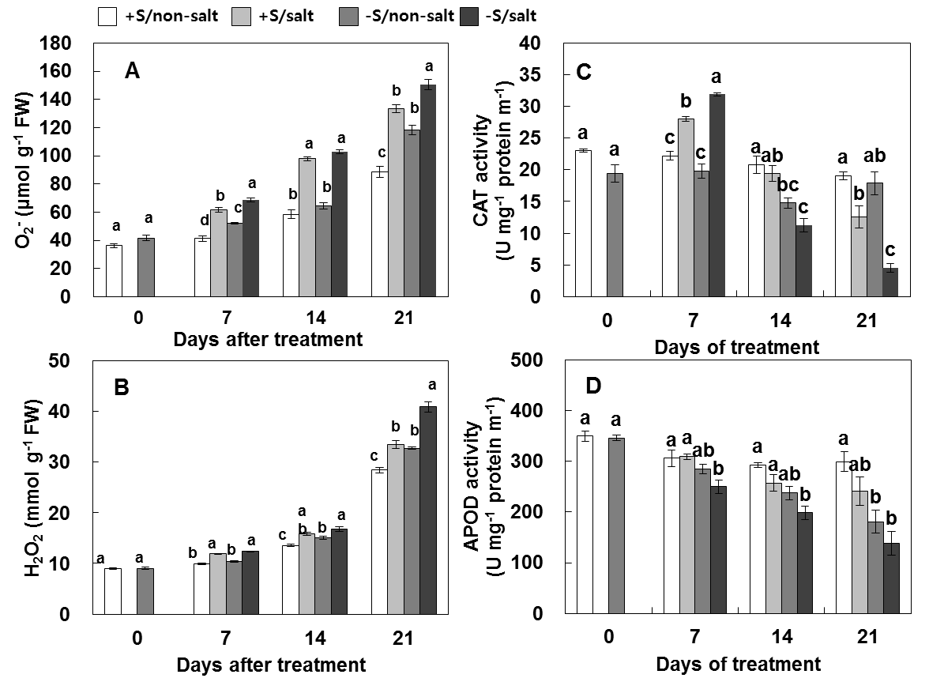
Figure 1. Changes in content of reactive oxygen species such as (A) O₂•─ and (B) H₂O₂, activities of (C) catalase (CAT) and (D) ascorbate peroxidase (APOD) of four sulfur and salt stress combined treatments; sufficient S without salt stress (+S/non-salt, control), sufficient S with salt stress (+S/salt), deprived S without salt stress (-S/non-salt), and deprived S with salt stress (-S/salt) in Kentucky bluegrass for 21 days. Bars labeled with the same letters are not significantly different (p>0.05) according to Duncan’s multiple range test. Vertical bars represent mean ± SE for n=3.

Many studies documented the changes in antioxidant enzyme activities in response to salt, suggests that the induction in these activities can be the basis for salt-stress tolerance (Hernández et al. 2000; Shalata et al. 2001). In this study, CAT activity was significantly decreased by 53 % in absence of S-nutrition (-S/salt) whereas it was not significantly decreased in presence of S-nutrition (+S/salt) at day 21 (Figure 1C). Salt-stress largely decreased the activity of APOD by 73 % in absence of S-nutrition (-S/salt), however, the rate of decrease was much lower (19 %) in presence of S-nutrition (+S/salt) at day 14. Salt-stress decreased the APOD activity at day 7 both in the presence or absence of S-nutrition compare to control at day 21 (Figure 1D). Therefore, these results suggest that S-nutrition reduces the accumulation of ROS accumulation as O₂•─and H₂O₂, and alleviates the oxidant stress.

Sulfur effects on antioxidative system under iron deficiency condition
Accumulation of oxidative stress was visualized in situ in the form of H₂O₂ and O₂•─ by histochemical methods. S-deprived leaves exhibited highly enhanced O₂•─ as brownish staining indicated by white arrows (Figure 2A). The staining was not increased in the +S/-Fe leaves compared to controls. In the both -S/+Fe and -S/-Fe leaves, dark brown spot areas for H₂O₂ were widespread, whereas the accumulation of these oxy radicals was largely reduced in the presence of S (+S/+Fe, +S/-Fe) (Figure 2B).

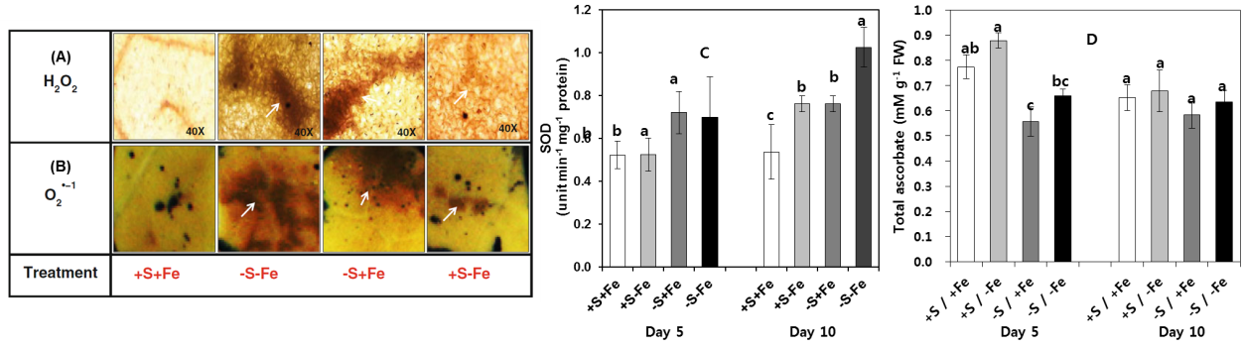
Figure 2. Localization of (A) O₂•─ and (B) H₂O_{2,} (C) superoxide dismutase (SOD) activity, and (D) ascorbate content. as affected by four S/Fe combined treatments; sufficient in S and Fe (+S/+Fe, control white bars), deprived S and Fe (-S/-Fe dark grey bars), deprived S but sufficient Fe (-S/+Fe light grey bars) and sufficient S but deprived Fe (+S/-Fe black bars) for 10 days in Brassica napus. Bars labeled with the same letters are not significantly different (p>0.05) according to Duncan’s multiple range test. Vertical bars represent mean ± SE for n=3.

Oxidative damage has been considered as one of the phytotoxic of reactive oxygen species (ROS) generation (Ali et al. 2005). Superoxide dismutase (SOD) is one of main consequence in ascorbate-glutathione cycle to detoxify the ROS. In this study, SOD activity was significantly increased by S-deprivation either with or without Fe at day 5 compared to control (Figure 2C). After 10 days treatment, S-and/or Fe-deprivation increased activity of SOD and the highest increase was observed in –S/-Fe treatment. Ascorbate and glutathione are the major antioxidants in plants. In our study, total ascorbate concentration was reduced by S- or Fe-deficiency. However, it was increased by presence of sulfur in absence of Fe deficiency (Figure 2D). These results showed that Fe deficiency increased the production of ROS and resulted in oxidative stress, and S-availability might alleviate the oxidative stress.

Sulfur effects on photosynthetic organelle system under salt stress condition
Salt-stress affected to photosynthetic pigments like chlorophyll and carotenoid (Figure 3A; 3B). From day 7, salt-stress seriously resulted in the decrease of chlorophyll and carotenoid content both in presence or absence of S. Similar result has been report in haematococcuspluvialis under salt-stress (Sarada et al. 2002). However, the extent of the decrease in chlorophyll and carotenoid content was largely reduced by S supply, showing 28% and 34% increase in presence of S-nutrition (+S/salt), respectively. The results obtained suggested the loss of photosynthetic pigment in S-nutrient compared S-deprivation, suggesting the possible influence of S under salt stress is positively alleviated by S-nutrition. The proteomic analysis of multiple protein complexes in the thylakoid by BN-PAGE showed in Figure 3C. The Kentucky bluegrass BN gel profile showed an interesting band identified as subcomplexes of PSI, PSII and RuBisCO. The intensity of PSI, PSII-core dimer super complex bands and RuBisCO reduced in S-deprived plants (-S/non-salt) and decreased further in the absence of S under salt- stressed plants (-S/salt), whereas these bands were abundant in the presence of S under salt-stressed plants (+S/salt) to the level of control. PSII core dimer and PSI (RCI-LHCI) complex bands were more affected. In synechococcus, salt-stress inactivated both PSI and PSII because the change in K/Na ratio (Allakhverdiev et al. 2000). In plants, RuBisCO is the key enzyme which is responsible for the primary step in CO₂ fixation and its carboxylating capacity can be the limiting factor in photosynthesis (Woodrow and Berry 1988). Sulfur-deprivation resulted in a decrease of the RuBisCO activity in leaves from Day 0 (Figure 3D). At day 21, salt-stress in the absence of S (-S/salt) rapidly decreased RuBisCO activity by 80% compared control, but the rate of decrease was much lower (62%) in the presence of S (+S/salt). These results showed that the loss of photosynthetic pigments and the depressed RuBisCO under salt-stressed condition were positively alleviated by sulfur nutrition.

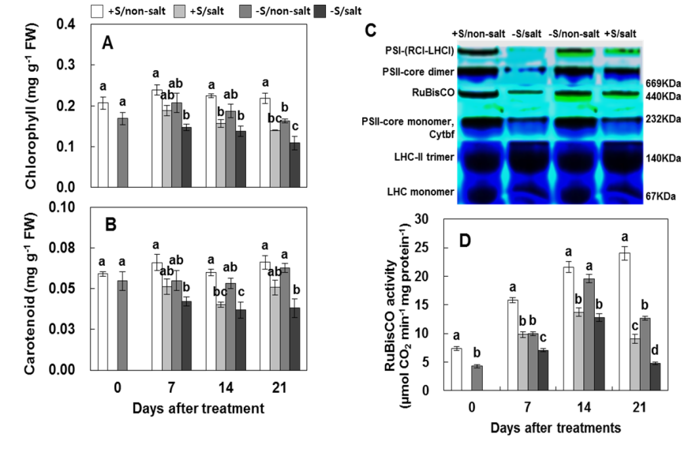
Figure 3. Changes in photosynthetic pigments such as (A) chlorophyll and (B) carotenoid, (C) multiple protein complexes in the thylakoid by BN-PAGE, and (D) RuBisCO activity of four sulfur and salt stress combined treatments; sufficient S without salt stress (+S/non-salt, control), sufficient S with salt stress (+S/salt), deprived S without salt stress (-S/non-salt), and deprived S with salt stress (-S/salt) in Kentucky bluegrass for 21 days. Bars labeled with the same letters are not significantly different (p>0.05) according to Duncan’s multiple range test. Vertical bars represent mean ± SE for n=3.

Sulfur effects on expression of proteins under iron deficiency condition
Three hundred proteins were reproducibly detected on on 2D gels by S and Fe combined treatments. Twelve protein spots were absent in sulfur deprivation condition (Figure 4B, indicated by green arrows on control gel). The loss of proteins might be due to degradation of specific enzymes related to sulfur or Fe assimilation such as glutathione or cysteine (Astolfi et al. 2010) which in turn limits the activity of protein synthesis and amino acids. However, 13 protein spots (spots 1-9, 11-14) were up-regulated and 2 proteins spot (spots 10, 15) were down-regulated under S-deprived condition with Fe-deprived condition (-S/-Fe) (Figure 4B, indicated by red arrows).
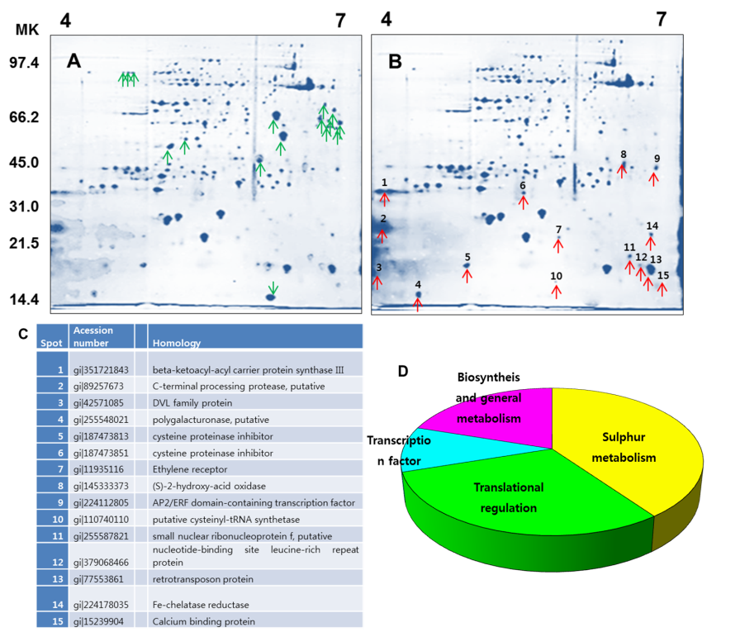

Figure 4. 2D references images of four S/Fe combined treatments; (A) sufficient in S and Fe (+S/+Fe, control) and (B) deprived S and Fe (-S/-Fe) in roots of Brassica napus. (C) Identification of differentially expressed proteins under S/Fe combined treatment. (D) Functional classification of identified proteins from leaves analyzed by MALDI-TOF-MS as described by Beven et al. (1998).

These proteins spots were identified by MALDL-TOF-MS (Figure 4C). The seven proteins up-regulated by –S/-Fe treatment were S and Fe related proteins such as Fe-related chelates, enzymes involved in Fe uptake, induction of cysteine and phytochelatins. However, these proteins were recovered by sulfur nutrition in Fe deprived roots. The proteins identified from roots were also classified into four categories (Figure 4D) as 40% S/Fe related proteins, 30% transcriptional regulation, 10% transcription factor and 20% biosynthesis and general metabolism. ). Taken together, the results indicate that S-nutrition has a more influential role in modulating the protein expression to alleviate deleterious impacts of Fe deficiency in the roots of oilseed rape plants.

Acknowledgments
This work was carried out with the support of "Cooperative Research Program for Agriculture Science & Technology Development (PJ010099)" Rural Development Administration, Republic of Korea.

References
Ali MB, Hahn EJ, Paek KY (2005) Effect of temperature on oxidative stress defense systems, lipid peroxidation and lipoxygenase activity in Phalaenpopsis. Plant Physiology and Biochemistry, 43: 213–223.
Allakhverdiev S I, Sakamoto A, Nishiyama Y, Inaba M, Murata N (2000) Ionic and osmotic effects of NaCl-inducedinactivation of photosystem I and II in Synechococcus sp. Plant Physiology, 123: 1047–1056.
Armstrong GA, Hearst JE (1996) Carotenoids 2: genetics and molecular biology of carotenoid pigment biosynthesis. FASEB Journal, 10: 228–237.
Astolfi S, Cesco S, Zuchi S, Neumann G, Roemheld V (2006) Sulphur starvation reduces phytosiderophores release by Fe-deficient barley plants. Soil Science & Plant Nutrition, 52: 80–85.
Astolfi S, Zuchi S, Neumann G, Cesco S, Sanita di Toppi L, Pinton R (2012) Response of barley plants to Fe deficiency and Cd contamination as affected by S starvation. Journal of Experimental Botany, 63(3): 1241–1250.
Balk J, Pilon M (2011) Ancient and essential: the assembly of iron–sulfur clusters in plants. Trends in Plant Science, 16: 218–226
Bowler C, Monagu MV, Inze D (1992) Superoxide dismutases and stress tolerance. Annual Review of Plant Physiology and Plant Molecular Biology, 43: 83–116.
Cai Y, Cao F, Cheng W, Zhang G, Wu F (2011) Modulation of exogenous glutathione in phytochelatins and photosynthetic performance against cd stress in the two rice genotypes differing in Cd tolerance. Biological Trace Element Research, 143:1159–1173.
Cao X, Ma LQ, Tu C (2004) Antioxidative responses to arsenic in arsenichyper accumulator Chinese brake fern (Pterisvittata L.). Environmental Pollutution, 128: 317–325.
Davidian JC, Kopriva, S (2010) Regulation of sulfate uptake and assimilation – the same or not the same? Molecular Plant, 3: 314–325.
Fontes RLF, Cox FR (1995) Effects of sulfur supply on soybean plants exposed to zinc toxicity. Journal of Plant Nutrition, 18: 1893–1906.
Hernández JA, Jimenez A, Mullineaux P, Sevilla F (2000) Tolerance of pea (Pisum sativum L.) to long-term salt stress is associated with induction of antioxidant defenses. Plant Cell and Environment, 23: 853–862.
Hippler M, Klein J, Fink A, Allinger T, Hoerth P (2001) Towards functional proteomics of membrane protein complexes: analysis of thylakoid membranes from Chlamydomonas reinhardtii. Plant Journal, 28: 595–606.
Juszczuk IM, Ostaszewska M (2011) Respiratory activity, energy and redox status in sulphur-deficient bean plants. Environmental and Experimental Botany, 74: 245–254.
Khan MA, Ungar IA, Showalter AM, Dewald HD (1998) NaCl-induced accumulation of glycinebetaine in four subtropicalhalophytes from Pakistan. Physiologia Plantarum, 102: 487–492.
Kiraly L, Kunstler A, Holler K, Fattinger M, Juhasz C, Muller M, Gullner G, Zechmann B (2011) Sulfate supply influences compartment specific glutathione metabolism and confers enhanced resistance to Tobacco mosaic virus during a hypersensitive response. Plant Physiology and Biochemistry, 59: 44–54.
Lee BR, Muneer S, Kim KY, Avice JC, Ourry A, Kim TH (2013) S-deficiency responsive accumulation of amino acids is mainly due to hydrolysis of the previously synthesized proteins – not to de novo synthesis in Brassica napus. Physiologia Plantarum, 147: 369– 380.
Naumann B, Stauber EJ, Busch A, Sommer F, Hippler M (2005) N-terminal processing of Lhca3 is a key step in remodelling of the photosystem I-light-harvesting complex under iron deficiency in Chlamydomonas reinhardtii. The Journal of Biological Chemistry, 280: 20431–20441.
Sarada R, Tripathi U, Ravishankar GA (2002) Inﬂuence of stress on astaxanthin production in Haematococcuspluvialis grown under different culture conditions. Process Biochemistry, 37: 623–627.
Shalata A, Mittova V, Volokita M, Guy M, Tal M (2001) Response of the cultivated tomato and its wild salt-tolerant relativeLycopersiconpennellii to salt-dependent oxidative stress: the rootantioxidative system. Physiologia Plantarum, 112: 487–494.
Williams JS, Hall SA, Hawkesford MJ, Beale MH, Cooper RM (2002) Elemental sulfur and thiol accumulation in tomato and defense against a fungal vascular pathogen. Plant Physiology, 128: 150–159
Zuchi S, Cesco S, Astolfi S (2012) High S supply improves Fe accumulation in durum wheat plants grown under Fe limitation. Environmental and Experimental Botany, 77: 25–32.

[Sample of Poster Presentations] :: Full paper for poster presentation: 2 pages
Prediction of fermentation quality in undried corn silage by near infrared reflectance spectroscopy

H. S. Park, S. H. Lee, J. G. Kim, K. C. Choi, E. M. Choi, W. H. Kim and Y. C. Lim

Grassland & Forages Division, National Institute of Animal Science, RDA, 330-801, Korea.

Keywords: near infrared reflectance spectroscopy, corn silage, fermentation quality

Abstract
Corn silage samples (n=112) were collected from dairy farms in Korea. Each sample was subdivided into two treatments: i) Intact fresh (IF); ii) Liquid nitrogen grinding (LNG). From these treatments, calibration equations were developed successfully for concentrations of all constituents except butyric acid. Prediction accuracy, represented by standard error of prediction (SEP) and R²v(variance accounted for in validation set), was slightly better with the LN treatment (R² 0.75-0.90) than for IF (R² 0.62-0.79) treatments. Although statistical results for the IF treatments was the lower than those of LN treatment, intact fresh (IF) treatment may be acceptable when processing is costly or when possible component alterations are expected.

Introduction
Near infrared reflectance spectroscopy (NIRS) has become increasingly used as a rapid, accurate method of evaluating some chemical constituents in cereal grains and forages. If samples could be analyzed without drying and grinding, then sample preparation time and costs may be reduced. Using NIRS directly on undried silage can increase error due to variability in sample particle size, temperature and water content (Givens, et al., 1997). These problems can be overcome by grinding silages in frozen state with dry ice or liquid nitrogen, but such procedures are time-consuming and inconvenient due to cleanup required between samples and the need to thaw the sample for subsequent use. The objective of this experiment was to assess the effect of sample preparation methods on prediction of fermentation quality of corn silage, and to select an acceptable sample-preparation method for wet silage.

Materials and methods
Corn silage samples (n=112) were collected from dairy farms in Korea. Each sample was subdivided into two treatments: i) Intact fresh (IF); ii) Liquid nitrogen grinding (LNG). For LNG, samples were immersed in liquid nitrogen (-196°C) for 30 min, then grinding. Concentrations of volatile fatty acids and lactic acid were determined based on methods of Fussell and McCalley (1987). Samples were scanned from 400 to 2,500 nm with an NIRS 6,500 monochromator. The samples were divided into calibration and validation sets. The spectral data were regressed on a range of dry matter (DM), pH and short chain organic acids using modified multivariate partial least squares (MPLS) regression with internal cross-validation after scatter correction using SNV and Detrend.
Results
Comparisons of NIR predicted parameters for three sample preparation methods of corn silage are shown in Table 1. Predictions of acetic acid concentrations were achieved with best accuracy in their intact fresh condition. The best predictions of propionic acid concentrations were obtained with LNG treatment (SEP=0.08, R²=0.65), but IF preparation methods produced poor validation R². None of the NIRS calibration equations were satisfactory for the estimation of butyric acid. This is possibly due to either no detectable or the lower concentration of butyric acid in good fermentation corn silage samples. The best predictions of lactic acid concentrations were obtained using IF preparation methods.

Table 1. Accuracy of NIRS in sample preparation methods for volatile fatty acids and lactic acid
Parameters | Sample  preparation | Calibration |  |  |  |  | Validation
Parameters | Sample  preparation | R² | SEC | SECV | 1-VR |  | SEP | R²
DM(%) | IF | 0.83 | 1.40 | 1.55 | 0.79 |  | 1.38 | 0.69
 | LNG | 0.93 | 1.30 | 1.30 | 0.87 |  | 1.05 | 0.81
pH(1:5) | IF | 0.74 | 0.08 | 0.11 | 0.54 |  | 0.10 | 0.50
 | LNG | 0.81 | 0.06 | 0.09 | 0.63 |  | 0.06 | 0.85
Short chain organic acids (%, DM)
Acetic acid | IF | 0.95 | 0.10 | 0.19 | 0.85 |  | 0.13 | 0.89
 | LNG | 0.94 | 0.11 | 0.20 | 0.84 |  | 0.17 | 0.88
Propionic acid | IF | 0.63 | 0.09 | 0.11 | 0.44 |  | 0.12 | 0.27
 | LNG | 0.83 | 0.06 | 0.09 | 0.67 |  | 0.08 | 0.65
Butyric acid | IF | 0.19 | 0.003 | 0.004 | 0.04 |  | 0.007 | 0.00
 | LNG | 0.26 | 0.003 | 0.004 | 0.17 |  | 0.003 | 0.00
Lactic acid | IF | 0.90 | 0.43 | 0.64 | 0.78 |  | 0.75 | 0.77
 | LNG | 0.89 | 0.43 | 0.73 | 0.77 |  | 0.76 | 0.70
Total acid | IF | 0.83 | 0.58 | 0.74 | 0.73 |  | 0.74 | 0.57
 | LNG | 0.87 | 0.52 | 0.73 | 0.76 |  | 0.69 | 0.73
R², coefficient of determination; SEC, standard error of calibration; SECV, standard error of cross-validation; 1-VR, coefficient of determination for cross-validation; SEP, standard error of prediction.

Conclusions
The results of this study have shown that NIRS analysis of undried silages can provide accurate prediction of a wide range of fermentation products. Although predictions by NIRS analysis differ by sample preparation method, NIRS can be used as a screening tool to predict fermentation quality in wet corn silages.

References
Fussel, R. J. and D. V. McCalley (1987). Determination of volatile fatty acids (C2-C5) and lactic acid in silage by gas chromatography. Analyst. 112:1213-1216.
Givens, D.I., J.L. De Boever, and E.R. Deaville (1997). The principles, practices and some future applications of near infrared spectroscopy for predicting the nutritive value of foods for animals and humans. Nutrition
GUIDELINES FOR PREPARING POSTERS

The objective is to present a simple message visually. Each poster should facilitate the reader by giving a clear take-home message. The following should be observed:
1. Dimensions
All posters are required to conform to portrait orientation. Failure to follow this requirement will mean that the poster will not fit on the allotted board. Poster board dimensions are 84 cm wide × 119 cm long. Alternatively, a number of smaller sheets can be used to create a larger collage, but do not go beyond the board dimensions.

2. Layout
Divide the poster into sections e.g. Title, Message, Introduction, Materials and methods, Results and conclusions.

3. Design
Posters should be clear and easy to read. Type size should be sufficiently large to allow people to read from 2-3 meters: a minimum of 1 cm high for the text and 2.5 cm high for the title and subtitles. Do not reduce text size in order to fit more information onto the poster. Design the poster to convey a clear message. Avoid overload as too much information seriously detracts from the overall impact. The simple use of color can enhance a presentation, but avoid the temptation towards art! Consider the use of suitable photographs, but do not include them as a background to the poster.

Seongsan Ilchulbong  Tuff Cone | http://jejuwnh.jeju.go.kr/contents/index.php?mid=020202  
Hallasan Mountain  (Baengnokdam Crater Lake ) | www.hallasan.go.kr  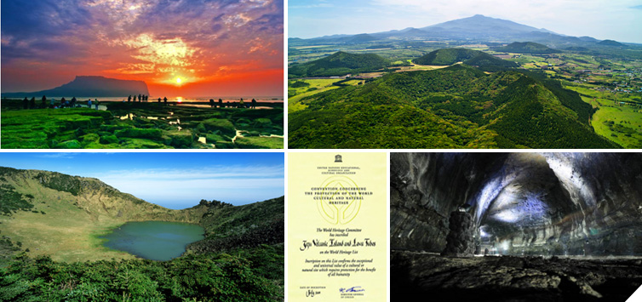
Seopjikoji Beach | http://korean.visitkorea.or.kr/kor/bz15/where/where_tour.jsp?cid=127813  
Yongmeori Beach | http://www.jejutour.go.kr/contents/index.2013.php?act=view&mid=TU&seq=287  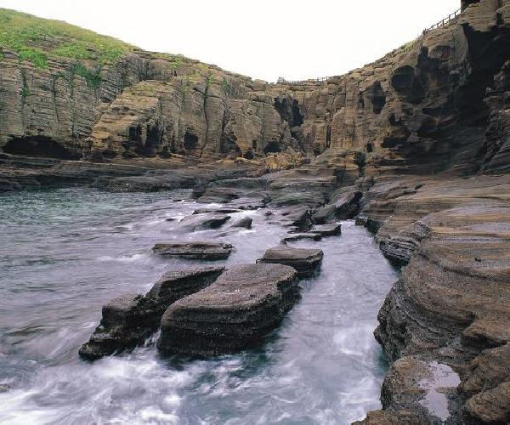
Saryeni forest path | http://www.jejutour.go.kr/contents/?act=view&mid=TU&seq=845  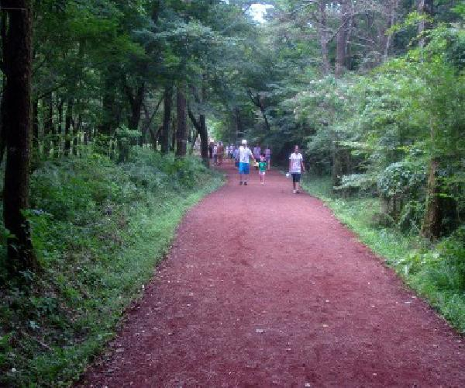
Jeongbang Falls | http://www.jejutour.go.kr/contents/?act=view&mid=TU&seq=394  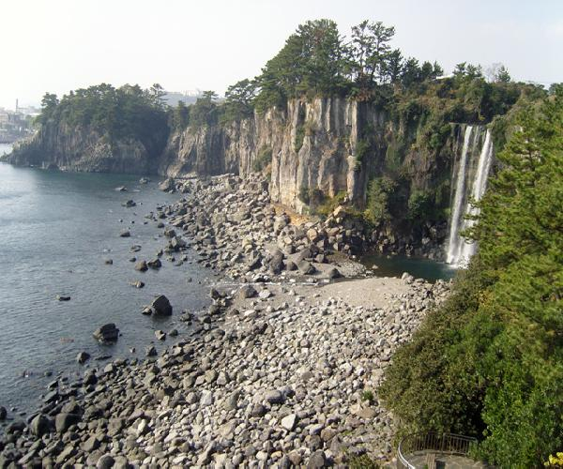
Halla Arboretum | http://sumokwon.jeju.go.kr/  